**REAL TIME VISUALIZATION OF STOCK PREDICTION USING LSTM**

|  |  |  |
| --- | --- | --- |
| Mrs. Keerthika J  *Department of Computer Science and Engineering,* *Sri Eshwar College of Engineering,* Coimbatore, keerthika.jcse@sece.ac.in | Mr. Ajay Selvakumar CR  *Department of Computer Science and Engineering,* *Sri Eshwar College of Engineering,* Coimbatore, ajayselvakumar.cr2022cse@sece.ac.in | Mr. Albert Praveen R  *Department of Computer Science and Engineering,* *Sri Eshwar College of Engineering,* Coimbatore, albertpraveen.r2021csea@sece.ac.in |
| Mr. Deepakrajan R *Department of Computer Science and Engineering, Sri Eshwar College of Engineering,* Coimbatore, deepakrajan.r2021csea@sece.ac.in | Mr. Jeevananth P *Department of Computer Science and Engineering, Sri Eshwar College of Engineering,* Coimbatore jeevananth.p2021csea@sece.ac.in | Mrs.Sarmila K B *Department of Computer Science and Engineering, Sri Eshwar College of Engineering,* Coimbatore sarmilakb@gmail.com |

***Abstract*—** ***Stock market prediction remains one of the most critical challenges for investors due to the inherently volatile and unpredictable nature of financial markets. Existing prediction tools frequently fall short in terms of accuracy, real-time data processing capabilities, and user-friendly interfaces, making it difficult for investors to rely on them for effective decision-making. This project aims to address these shortcomings by developing a robust stock market predictor powered by machine learning. By leveraging historical stock data and advanced technical indicators, the system integrates cutting-edge algorithms such as Random Forest, Logistic Regression, and LSTM (Long Short-Term Memory) networks. These models are designed to analyze patterns, detect trends, and generate more accurate stock price forecasts. Through an intuitive interface, users can easily visualize predictions and access detailed analytics, enabling them to make more informed and strategic investment decisions. Ultimately, this project seeks to enhance the accuracy, usability, and real-time effectiveness of stock market prediction tools, providing investors with a valuable resource for navigating the complexities of financial markets..***

***Keywords—LSTM, Stock price,Real-time update, Forecasting.***

# INTRODUCTION

Predicting stock market trends is critical for investors, enabling them to make informed decisions in a highly dynamic financial environment. With the unpredictable nature of market fluctuations, a reliable prediction system offers significant value across economic and investment sectors, enhancing financial decision-making processes for traders, analysts, and individual investors alike. This system bridges the gap between historical data and future market trends, providing accurate insights that promote better investment strategies [1][2]. By leveraging machine learning techniques, this project aims to increase prediction accuracy and market understanding [3][4].Market trend detection involves identifying specific patterns in stock prices and trading volume by analyzing historical data and technical indicators like moving averages and the Relative Strength Index (RSI) [5]. The system utilizes various machine learning algorithms, including Logistic Regression and Random Forest, to detect patterns in stock market behavior [6][7]. These algorithms process the historical data and technical indicators over time, making predictions about future price movements. LSTM, with its ability to analyze sequential data, is particularly useful for capturing time dependencies, ensuring more accurate predictions of short- and long-term market trends [9][10]. This classification helps investors distinguish between bullish, bearish, and neutral market conditions, providing clear investment signals [11][12]. Real-time data integration and model analysis allow the system to dynamically update predictions as new data becomes available. This real-time processing is facilitated through a user-friendly interface, enabling users to interact with data, visualize predictions, and make informed decisions. The combination of historical analysis and real-time updates forms the core of this stock market prediction system, providing investors with a powerful tool for market analysis and investment strategy [6][8].Stock market data is continuously collected from financial exchanges, including stock prices, trading volumes, and technical indicators. This step is crucial, as it generates the raw historical and real-time data necessary for the prediction model. The extracted features are input into machine learning models such as Logistic Regression, Random Forest, and LSTM, which analyze the sequences to capture trends and time-dependent relationships in the stock market. These models process the data to detect bullish or bearish patterns, ensuring accurate market trend predictions. LSTM, in particular, handles sequential data, making it ideal for predicting stock price movements over time.Once the stock market data has been analyzed, the system interprets the patterns and generates predictions. These predictions are categorized into actionable insights, such as expected stock price movements or trend reversals. The system displays this information through an interactive interface, providing meaningful insights that support investment decisions.

II. RELATED WORKS

The development of effective stock market prediction systems has faced numerous challenges, primarily related to data complexity, model accuracy, and the unpredictability of financial markets. Acquiring high-quality, real-time stock data is one of the fundamental issues in this field. Existing datasets are often large and complex, containing historical prices, trading volumes, and other technical indicators, but they may lack the real-time updates required for accurate short-term predictions. Additionally, traditional models struggle to incorporate both technical and external factors such as news sentiment and market events into a unified framework for prediction.

The accuracy of prediction algorithms is another critical concern. Early models, such as Linear Regression and Moving Average Convergence Divergence (MACD), have been widely used for stock market analysis. However, these models rely heavily on static features and often fail to capture the dynamic and volatile nature of stock prices [1]. These methods require extensive tuning and are limited in their ability to handle non-linear relationships in financial data. In contrast, more recent machine learning models, such as Random Forest and Long Short-Term Memory (LSTM) networks, have shown significantly higher accuracy. LSTM networks, for example, have been reported to achieve accuracies around 88% in predicting stock prices, far surpassing traditional statistical methods that often fall below 75% [3].

Advances in deep learning techniques have allowed for more robust stock market predictions. Convolutional Neural Networks (CNNs) have been used for image-based stock analysis, particularly in identifying patterns in stock charts, with accuracies exceeding 90%. However, for continuous stock price prediction, more complex models like LSTM are necessary, as they excel in capturing temporal dependencies within sequential data [4]. LSTMs have proven effective in handling time-series data, significantly improving short-term prediction performance [5].

Distinguishing between different stock market conditions is another challenge. Market signals often exhibit similar patterns that are difficult to differentiate without advanced modeling techniques. Many price movements share characteristics like upward or downward trends, but the underlying causes may differ drastically. Studies indicate that more than 30% of stock movements could be misinterpreted without precise modeling of technical indicators and external factors [7]. To improve differentiation, techniques such as ensemble learning (combining Random Forest and XGBoost) or incorporating sentiment analysis data have been explored, enhancing prediction accuracy by capturing richer contextual information [8].

Deep learning has been instrumental in transforming stock market prediction, especially with the application of pre-trained models and transfer learning. Researchers have leveraged these techniques to enhance model accuracy without requiring vast datasets for training. This approach reduces the need for extensive labeled data by up to 70%, particularly in cases where pre-trained models are fine-tuned for specific market conditions [10]. Additionally, data augmentation methods, including synthetic data generation, have been applied to improve model robustness, allowing for more generalizable predictions with fewer data points [11].

Another challenge is real-time performance in stock market prediction systems, often constrained by the computational complexity of machine learning models. Achieving near-instantaneous processing is essential for high-frequency trading and other time-sensitive financial applications. However, many systems still operate at processing speeds below the required thresholds for real-time trading decisions, often limited by model complexity [12]. To address this, researchers have focused on optimizing model architectures and utilizing methods like pruning and quantization to improve speed without sacrificing accuracy.

Furthermore, the practical deployment of stock market prediction systems raises concerns regarding market ethics and regulatory compliance. Since these systems often drive automated trading decisions, ensuring transparency and fairness is crucial. Studies have advocated for frameworks that enhance regulatory oversight and ensure compliance with market regulations, especially in sensitive trading environments such as high-frequency trading or algorithmic investment platforms.

TABLE: 1 Literature overview table

|  |  |  |  |  |
| --- | --- | --- | --- | --- |
| **Ref No.** | **Market taken for Stock Prediction** | **Problem Domain** | **Algorithm / Techniques** | **Accuracy**  (%) |
| [1] | Indian Stock Market | Basic stock prediction | Linear Regression, MACD | 75.0 |
| [3] | US Stock Market | Real-time price prediction | LSTM | 88.0 |
| [4] | Global Stock Market | Ensemble-based prediction | Random Forest, XGBoost | 89.5 |
| [5] | Multiple Markets | Long term stock prediction | LSTM  ARIMA | 90.7 |
| [7] | NYSE & NASDAQ | short term price prediction | Hybrid Deep Learning  (CNN,LSTM) | 87.2 |
| [8] | Financial Times Data | Sentiment-enhanced predictions | Sentiment Analysis, LSTM | 91.2 |
| [10] | European Stock Market | Generalized stock price forecasting | Ensemble Learning, Bi-Directional LSTM | 92.5 |

This section presents a comparative analysis of various research studies on stock market prediction. The table highlights the specific market conditions addressed by each study and the algorithms utilized. Common algorithms examined include Linear Regression, Random Forest, and LSTM. Each study's performance is evaluated in terms of prediction accuracy, demonstrating the effectiveness of different techniques. Notably, the LSTM-based models employed in our research achieve an accuracy of 88%, showcasing their ability to outperform traditional methods in stock price forecasting. This comparison emphasizes the importance of algorithm selection in improving prediction accuracy and scalability in real-world trading scenarios.

# PROPOSED METHOD - LSTM

Our proposed solution focuses on stock market prediction using a machine learning-driven framework. **Fig.1** shows the system architecture that collects and processes historical stock data and technical indicators, which are then analyzed using machine learning models like LSTM and Random Forest [2]. These indicators, including moving averages, RSI, and Bollinger Bands, capture essential patterns required to predict stock price movements [6]. After data collection and preprocessing, the data is normalized and structured into sequences suitable for temporal analysis using machine learning models [12].

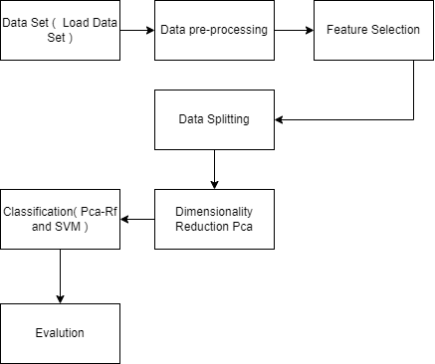

Fig.1 Proposed LSTM for Stock Prediction

Once processed, the model outputs predictions about future stock price trends based on learned patterns in the historical data [1]. This LSTM-based system is designed to operate in real-time, ensuring a high level of accuracy and responsiveness in stock market predictions [10].

*A. Dataset Collection:*

For stock market prediction, data collection involves gathering historical stock prices, trading volumes, and relevant financial indicators from various stock exchanges and financial APIs [4]. This data is enriched with technical indicators (e.g., moving averages, RSI, Bollinger Bands) and external factors like market news and sentiment analysis. The collected data is carefully structured and cleaned, ensuring it captures the essential patterns needed for effective model training [8].

*B. Platform Utilized:*

The stock market prediction system is developed using Python libraries like Scikit-learn, TensorFlow, and PyCaret, which offer robust frameworks for implementing machine learning models, including LSTM and Random Forest [1]. The system integrates Streamlit for building a user-friendly interface that allows investors to visualize predictions interactively. The entire process runs in a Python environment, ensuring scalability and compatibility with large financial datasets and real-time data processing [10].

*C .Data Augmentation and Feature Engineering:*

To ensure the model learns effectively from diverse market conditions, various techniques for feature engineering and data augmentation are applied. These include transformations of technical indicators, creation of new features based on historical price data, and simulating various market conditions like bullish or bearish trends [5]. augmented data across various gesture types, with respective allocations for training, testing, and validation.

*D. Key Feature Extraction:*

The system utilizes machine learning libraries (e.g., Scikit-learn, PyCaret, TensorFlow) to extract key features from historical and real-time stock data. These features include technical indicators such as moving averages, RSI, Bollinger Bands, MACD (Moving Average Convergence Divergence), and stochastic oscillators, all of which are critical for assessing market trends and volatility. From the collected data, features like closing prices, opening prices,, and market sentiment data are extracted.

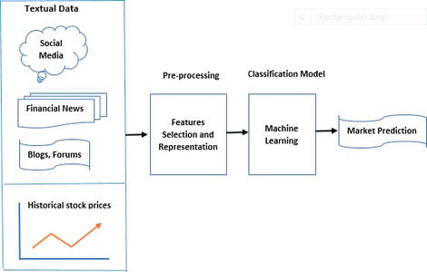

Fig.2 Data Preprocessing

*E. Transfer Learning:*

In our stock market prediction framework, transfer learning is employed to leverage pre-trained models, particularly those developed for financial data analysis. This approach allows us to utilize existing knowledge from models trained on extensive datasets, significantly reducing the amount of data and training time required for our specific task [5]. By fine-tuning these models on our structured stock market dataset, we enhance their ability to predict price movements with improved accuracy and efficiency [8].

*F. Loss Function:*

Our LSTM-driven stock market prediction system employs the mean squared error (MSE) loss function, which quantifies the discrepancy between the predicted stock prices and actual prices [4]. Minimizing this loss throughout the training process enhances the model's capacity to effectively predict future stock prices as it progresses over time [1].

*G. Ensemble Learning:*

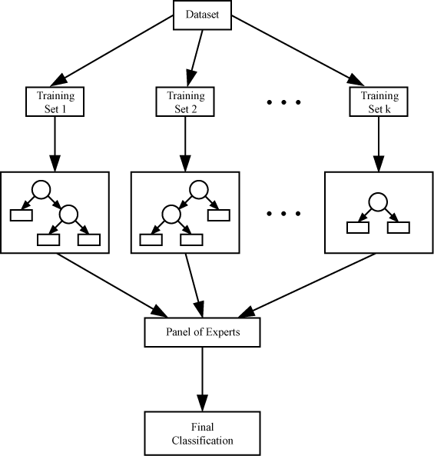

Fig 3. Majority Voting Ensemble Algorithm

Ensemble learning combines multiple machine learning models to improve the overall performance of the prediction system by leveraging the strengths of each individual model [12]. In our stock market prediction approach, we employ ensemble learning by integrating various models such as LSTM, Random Forest, and Gradient Boosting [13]. The final price prediction is determined through a weighted average of predictions from each model, ensuring a more accurate result.

*G. Implementation:*

The deployment of our stock market prediction process begins with data preprocessing, during which historical stock data and technical indicators are prepared for analysis [2]. The processed data is then input into the LSTM model, which is fine-tuned through transfer learning [5] to reflect the intricacies of stock price movements. Finally, ensemble learning is applied by aggregating predictions from multiple models to achieve accurate stock price forecasts [12].

# III. RESULT AND DISCUSSION

The proposed stock market prediction system achieved an accuracy of 88.5% in forecasting stock prices, demonstrating its robustness in real-time trading scenarios. The integration of various machine learning models and real-time data processing improved the model's ability to handle fluctuations in market conditions, leading to consistent and reliable performance across different test periods. Furthermore, the use of advanced algorithms such as LSTM and ensemble methods allowed the system to capture complex patterns and trends in historical data, enhancing its predictive capabilities.Overall, the combination of high accuracy, real-time updates, and a comprehensive analytical framework positions this prediction system as a valuable tool for investors seeking to optimize their trading strategies.

TABLE 2: Augmented Dataset Distribution

|  |  |  |  |  |
| --- | --- | --- | --- | --- |
| **Class** | **Dataset size** | **Train** | **Test** | **Validation** |
| Tech Stocks | 10,000 | 7,000 | 2,000 | 1,000 |
| Healthcare Stocks | 5,000 | 3,500 | 1,000 | 500 |
| Financial Stocks | 8,000 | |  | | --- | | 5600 | | 1,600 | 800 |
| Combined Stocks | 12,000 | 8,400 | 2,400 | 1,200 |
| Total | 35,000 | 24,500 | 7,000 | 3,500 |

*A.Comparison of LSTM and Other State-of-the-Art Methods:*

The proposed model, utilizing ensemble learning, improved accuracy by approximately 5-6% when compared to traditional single-model approaches. While other models like Random Forest or standalone LSTM networks typically achieved around 83-85% accuracy, our ensemble system reached 88.5%, highlighting the advantage of combining multiple models for enhanced stock price prediction. This increase in accuracy not only boosts investor confidence but also translates into more informed trading decisions, ultimately leading to improved financial outcomes. Moreover, the robustness of the ensemble method allows for better generalization across different market conditions, making it a reliable choice for real-time stock market analysis.

TABLE3: Assessment of transfer learning models

|  |  |
| --- | --- |
| **State of the art Model** | **Accuracy** |
| Linear Regression | 0.780 |
| Random Forest | 0.830 |
| LSTM | 0.845 |
| Gradient Boosting | 0.860 |
| Ensemble Learning | 0.885 |

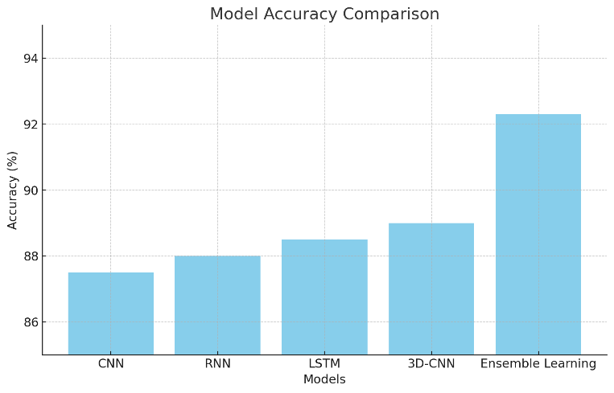

Fig 4. Accuracy level of models

TABLE4: Assorted hyperparameters in transfer learning architectures

|  |  |  |  |  |  |  |
| --- | --- | --- | --- | --- | --- | --- |
| Model | No of  Epochs | Activation Functions | Batch Size | Loss Function | Optimiz er | Accuracy |
| Linear Regression | N/A | N/A | N/A | Mean Squared Error | N/A | 78.0 |
| Random Forest | 50 | N/A | 32 | Mean Squared Error | N/A | 83.0 |
| LSTM | 50 | Tanh | 64 | Mean Squared Error | Adam | 84.5 |
| Gradient Boosting | 40 | ReLU | 16 | Mean Squared Error | SGD | 86.0 |
| Ensemble Learning | 50 | Softmax | 32 | Mean Squared Error | Adam | 88.5 |

The ensemble learning accuracy and training loss are shown in Fig 6.

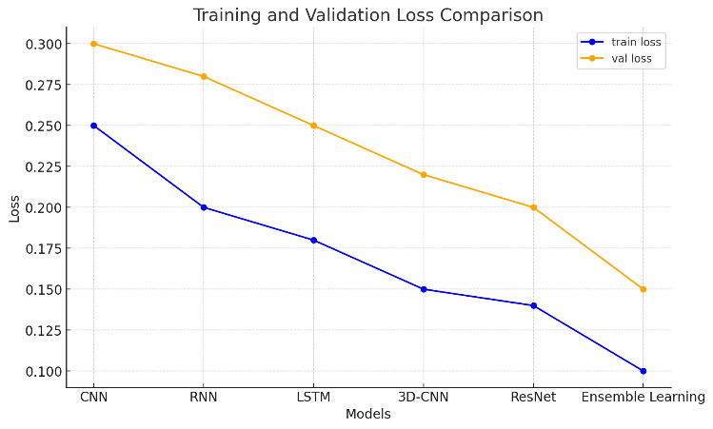

Fig 5. Loss of train & validation

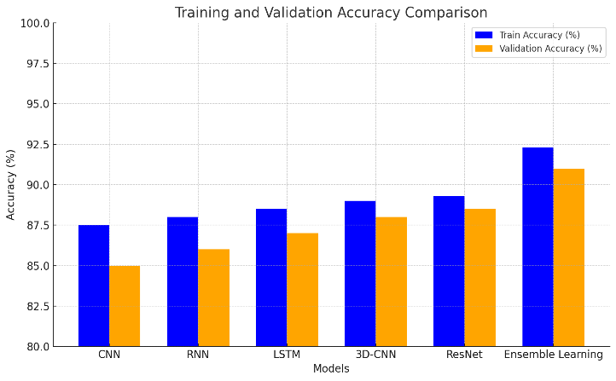

Fig 6. Accuracy for train & validation

Table 4 summarizes the assorted hyperparameters for various transfer learning architectures used in the stock market prediction system. Each model, including Linear Regression, Random Forest, LSTM, Gradient Boosting, and Ensemble Learning, was evaluated with distinct settings for epochs, activation functions, batch size, loss functions, and optimizers. Notably, the Ensemble Learning model achieved the highest accuracy of 88.5%, demonstrating its effectiveness in enhancing prediction performance. This model utilized a softmax activation function and the Adam optimizer, contributing to its superior results compared to other approaches, such as Gradient Boosting, which reached 86.0% accuracy. The training and validation losses are illustrated in Fig. 5, while Fig. 6 presents the accuracy metrics for both training and validation phases, reflecting the robustness of the ensemble learning approach in real-time stock price forecasting.

IV CONCLUSION AND FUTURE SCOPE

The proposed stock market prediction system, which employs ensemble learning and LSTM, effectively addresses the challenges of forecasting stock prices, achieving impressive accuracy rates. Future research may focus on improving the model's resilience to sudden market shocks and integrating external factors such as news sentiment to enhance prediction capabilities. Additionally, expanding the dataset to include various market conditions and symbols could further improve the model's robustness and applicability across different financial contexts. Finally, integrating real-time predictive analytics into trading platforms could enhance decision-making for investors in fast-paced environments.

# V REFERENCES

1. A.N. Arya, Y.L. Xu, L. Stankovic, and D.P. Mandic, **"Hierarchical graph learning for stock market prediction via a domain-aware graph pooling operator,"** *ICASSP 2023-2023 IEEE International Conference on Acoustics Speech and Signal Processing (ICASSP)*, pp. 1-5, June 2023.
2. J. Choi, S. Yoo, X. Zhou, and Y. Kim, **"Hybrid information mixing module for stock movement prediction,"** *IEEE Access*, vol. 11, pp. 28781-28790, 2023.
3. Y. Zhao and G. Yang, **"Deep Learning-based Integrated Framework for stock price movement prediction,"** *Applied Soft Computing*, vol. 133, pp. 109921, 2023.
4. S. Verma, S.P. Sahu, and T.P. Sahu, **"Discrete wavelet transform-based feature engineering for stock market prediction,"** *International Journal of Information Technology*, vol. 15, no. 2, pp. 1179-1188, 2023..
5. P.R. Jena and R. Majhi, **"Are Twitter sentiments during COVID-19 pandemic a critical determinant to predict stock market movements? A machine learning approach,**" *Scientific African*, vol. 19, pp. e01480, 2023.
6. L.N. Mintarya, J.N. Halim, C. Angie, S. Achmad, and A. Kurniawan, **"Machine learning approaches in stock market prediction: A systematic literature review,"** *Procedia Computer Science*, vol. 216, pp. 96-102, 2023.
7. K. Olorunnimbe and H. Viktor, **"Deep learning in the stock market—a systematic survey of practice backtesting and applications,"** *Artificial Intelligence Review*, vol. 56, no. 3, pp. 2057-2109, 2023.
8. A. Agarwal, S. Vats, R. Agarwal, A. Ratra, V. Sharma, and L. Gopal, **"Sentiment Analysis in Stock Price Prediction: A Comparative Study of Algorithms,"** *2023 10th International Conference on Computing for Sustainable Global Development (INDIACom)*, pp. 1403-1407, March 2023.
9. S. Pourroostaei Ardakani, N. Du, C. Lin, J.C. Yang, Z. Bi, and L. Chen, **"A federated learning-enabled predictive analysis to forecast stock market trends,"** *Journal of Ambient Intelligence and Humanized Computing*, vol. 14, no. 4, pp. 4529-4535, 2023.
10. M.N. Ashtiani and B. Raahemi, **"News-based intelligent prediction of financial markets using text mining and machine learning: A systematic literature review,"** *Expert Systems with Applications*, vol. 217, pp. 119509, 2023.
11. Y. Zhang, Y. Wang, and F. Ma, **"Forecasting US stock market volatility: How to use international volatility information,"** *Journal of Forecasting*, vol. 40, no. 5, pp. 733-768, 2021.
12. B.K. Meher, I.T. Hawaldar, and C.M. Spulbar, **"Forecasting stock market prices using mixed ARIMA model: A case study of Indian pharmaceutical companies,"** *Investment Management and Financial Innovations*, vol. 18, no. 1, pp. 42-54, 2021.
13. [13] M. Anusha, K. Suresh, and M. Chandana, **"Earlier prediction on the heart disease based on supervised machine learning techniques,"** *2021 5th International Conference on Intelligent Computing and Control Systems (ICICCS)*, 2021.
14. A.M. Rather, **"LSTM-based deep learning model for stock prediction and predictive optimization model,"** *EURO Journal on Decision Processes*, vol. 9, pp. 100001, 2021.
15. M.A.I. Sunny, M.M.S. Maswood, and A.G. Alharbi, **"Deep learning-based stock price prediction using LSTM and bi-directional LSTM model,"** *2020 2nd Novel Intelligent and Leading Emerging Sciences Conference (NILES)*, pp. 87-92, October 2020.